

ENDURO_XTRAINER_250_2T_MY22
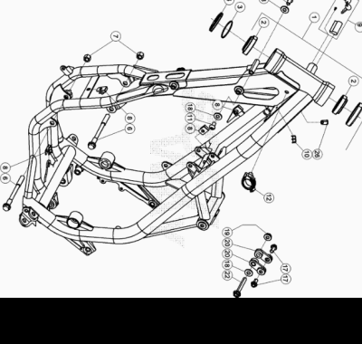

ENDURO_XTRAINER_250_2T_MY22
Ref. | Part Number | Description | Part
1 | 036.31.000.80.50 | CHASIS ANTERIOR XTRAINER | 1
2 | 12.99510.000 | COJINETE CÓNICO 29X50X15 RR-4T | 2
3 | 10.66935.000 | JUNTA TÓRICA RR-4T | 1
4 | 020.31.039.00.00 | GUARDAPOLVO DIRECCION | 1
5 | 25.98782.000 | PROTECCIÓN COJINETE DIRECCION RR-4T | 1
6 | 11.64607.000 | TORNILLO ESPECIAL RR-4T | 2
7 | 13.21060.000 | TUERCA AMBRIDADA M10 X 1,25 | 2
8 | 25.60311.000 | GRAPA TORNILLO M6 ALP 4.0 2008 | 4
9 | 28.85861.000 | CLAUSOR CERRADURA (Q20.30) RR. | 1
10 | 25.24443.000 | GUIA CABLE 6/6 RR-4T / RR 125 / RR-T | 1
11 | 31.64018.000 | TORNILLO M8X10 | 2
12 | 25.24440.000 | GUIA CABLES CHASIS SCOOTER | 1
17 | 11.54521.000 | TORNILLO 8.16 RS C/ARANDELA CH.10 | 2
18 | 27.49500.000 | ARANDELA PLANA 8.18 | 3
19 | 13.17123.000 | TUERCAS M8 | 1
20 | 036.31.042.80.00 | CONEXION MOTOR | 2
22 | 11.55950.000 | TORNILLO 8.60 PF CH 13 RS | 1
26 | 27.33741.000 | REMACHE | 1

ENDURO_XTRAINER_250_2T_MY22
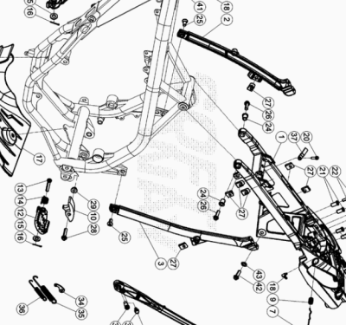

ENDURO_XTRAINER_250_2T_MY22
Ref. | Part Number | Description | Part
1 | 036.32.000.82.51 | CHASIS POSTERIOR | 1
2 | 020.32.100.00.59 | BRAZO CHASIS POSTERIOR DX | 1
3 | 020.32.027.42.59 | SOPORTE CHASIS POSTERIOR SX | 1
4 | 020.32.010.00.05 | CHAPA FIJ. CERRADURA | 1
5 | 020.32.112.00.00 | EJE CERRADURA | 1
6 | 020.32.011.00.05 | PLACA CERRADURA | 1
7 | 020.32.013.80.51 | BOTON CERRADURA FIJACION SILLIN | 1
9 | 020.32.016.00.00 | MUELLE | 1
10 | 25.25601.000 | PATIN TENSOR RR 4T 2008 | 1
11 | 25.32521.000 | ESTRIBERA DX ENDURO RR 4T | 1
12 | 25.32531.000 | ESTRIBERA SX ENDURO RR 4T | 1
13 | 25.54465.000 | EJE ESTRIBERA RR-4T | 2
14 | 016.32.020.00.00 | MUELLE ESTRIBERA | 2
15 | 031.32.001.00.00 | ARANDELA 10 X 21 X 2 | 2
16 | 12.81993.000 | PASADOR EJE ESTRIBERA | 2
17 | 036.32.002.00.00 | PROTECTOR CARTER | 1
18 | 27.23473.000 | RACORD PARA SFIATO ACEITE EVO/CR85 | 2
20 | 11.49070.000 | TORNILLO 6X20 RS CH8 | 3
21 | 020.32.004.00.00 | CASQUILLO SUPERIOR | 4
22 | 11.50355.000 | TORNILLO ANCLAJE M6X35 RS CH 8 | 4
23 | 31.29810.000 | TORNILLO TBCE 5.12 | 2
24 | 020.32.003.00.00 | CASQUILLO DELANTERO | 2
25 | 007.32.032.00.00 | TORNILLO ESP. TSBEI CH6 M8X20 10.9 ZINC | 2
26 | 31.64070.000 | TORNILLO ESPECIAL 8X25 CH10 | 2
27 | 25.60311.000 | GRAPA TORNILLO M6 ALP 4.0 2008 | 7
28 | 11.55480.000 | TORNILLO 8.40 PF C/ARANDELA | 1
29 | 13.17120.000 | TUERCA M8 BASE CILINDRO | 1
30 | 037.32.010.82.00 | KIT CABALLETE | 1
31 | 020.32.026.00.00 | MUELLE CABALLETE | 1
32 | 11.66615.000 | TORNILLO ESP. CAVALLETE RR 4T 2008 | 1
33 | 11.66614.000 | TORNILLO ESPECIAL CABALLETE RR 4T 2008 | 1
34 | 25.57636.000 | PLACA MUELLE CABALLETE RR-4T | 1
35 | 22.48819.000 | MUELLE CABALLETE EXTERIOR RR-4T | 1
36 | 22.48818.000 | MUELLE CABALLETE INFERIOR RR-4T | 1
37 | 036.32.004.15.00 | SOPORTE | 1
39 | 25.24430.000 | GUIA CABLE ADHESIVO SCOOTER | 1
41 | 28.91880.000 | SILENT-BLOCK CAREN.ESCAPE SCOOTER | 1
42 | 11.47015.000 | TORNILLO 6.12 REV3-04 - RR-4T | 1
43 | 27.42000.000 | ARANDELA PLANA 6.18 | 1

ENDURO_XTRAINER_250_2T_MY22
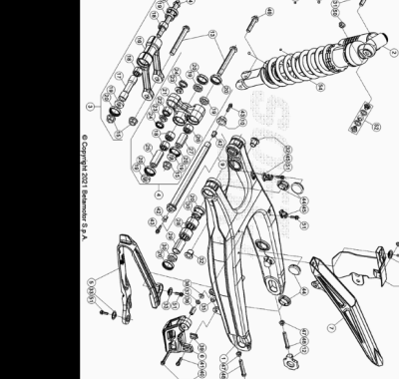

ENDURO_XTRAINER_250_2T_MY22
Ref. | Part Number | Description | Part
1 | 037.33.003.00.59 | BASCULANTE RR 2T MY 20 | 1
2 | 036.33.030.80.00 | AMORTIGUADOR XTRAINER 2T | 1
3 | 020.33.030.80.00 | BIELETA COMPLETA | 1
4 | 020.33.020.80.00 | TRAPEZIO COMPLETO | 1
5 | 020.33.015.00.00 | PROTECTOR CADENA SUP. | 1
6 | 037.33.004.00.00 | GUIACADENA | 1
7 | 12.88591.159 | #12.88591.000# | 1
8 | 12.88594.159 | CUBRECADENA INF RR 4 T | 1
9 | 031.33.142.80.00 | EJE BASCULANTE | 1
10 | 037.33.008.50.00 | TUERCA | 1
11 | 29.11866.100 | TENSOR CADENA IZQUIERDO RR-4T | 1
12 | 29.11865.100 | TENSOR CADENA DERECHO RR-4T | 1
13 | 11.63992.000 | TORNILLO 12.1,25.96 BIELETA RR-4T | 2
14 | 020.33.032.00.00 | TORNILLO ESPECIAL M 12 | 1
15 | 13.21130.000 | TUERCA 12 RR-4T | 3
16 | 020.33.030.00.00 | BIELETA | 1
17 | 020.33.031.00.00 | DISTANCIADOR | 1
18 | 11.22055.000 | COJINETE 20X26X16 RR-4T | 4
19 | 28.14083.000 | SOPERO BIELETAS RR-4T | 6
20 | 10.64481.000 | JUNTA ACEITE 25X32X7 RR-4T | 10
21 | 020.33.020.00.00 | TRAPECIO RR4T2010 | 1
22 | 16.17310.000 | GABIA 12.24.13 | 1
23 | 11.21920.000 | CASQUILLO TRAPECIO RR-4T | 2
24 | 10.56020.000 | RETEN 16.24.4 | 2
25 | 13.62813.000 | DISTANCIADOR 12X20X50 RR-4T | 1
26 | 11.22061.000 | COJINETE 20x26x30 | 1
27 | 13.62812.000 | DISTANCIADOR 12X20X40 RR-4T | 1
28 | 11.22056.000 | COJINETE 22X28X12 RR-4T | 4
29 | 13.49183.000 | DISTANCIADOR BASCULANTE RR-4T | 2
30 | 28.14081.000 | SOPERO BASCULANTE RR-4T | 4
31 | C24.31.050.00.00 | TORNILLO M. 10 X 40 1.25 | 1
32 | 020.33.001.00.00 | DISTANCIADOR BASCULANTE RR 4T 2010 | 2
33 | 27.74786.000 | ARANDELA RR-4T | 3
34 | 11.46360.000 | TORNILLO 5X16 LLAVE 8rs RR-4T | 2
35 | 13.12610.000 | TUERCA AUTOBLOCANTE GUIACADENA ENDURO 4T PS-M6-3 | 1
36 | 13.49191.000 | DISTANCIADOR RR-4T | 1
37 | 13.54820.000 | DISTANCIADOR RR-4T | 2
38 | 13.13020.000 | TUERCA M6 AUTOBLOC. BASSO | 1
39 | 13.48868.000 | DISTANCIADOR RR 4T 2008 | 1
40 | 11.05535.000 | TORNILLO 6,50 RS CH 8 RR-4T | 1
41 | 11.49070.000 | TORNILLO 6X20 RS CH8 | 1
42 | 27.33740.000 | REMACHE M. 6 | 2
43 | 11.46401.000 | TORNILLO 5X20 LLAVE 8rs RR-4T | 2
44 | 29.10596.136 | TAPON BASCULANTE DIÁMETRO 30 RR-4T | 4
45 | 15.14605.000 | BRIDA FIJACIÓN TUBO FRENO RR-4T | 2
46 | 036.33.027.00.00 | KIT RETENES | 1
47 | 13.17122.000 | TUERCA M8 ENDURO RR 125 | 2
48 | 11.55909.000 | TORNILLO 8X55 IF CH 10 ZB | 2
49 | 11.62050.000 | TORNILLO 10.45 RR-4T | 1
50 | 13.21060.000 | TUERCA AMBRIDADA M10 X 1,25 | 1
51 | 11.46251.000 | TORNILLO 5.12 RS CH8 | 4
52 | 036.33.013.00.00 | KIT ROTULAS AMORTIGUADOR | 1
53 | 036.33.023.00.00 | KIT SEEGERS Y ARANDELAS AMORTIGUADOR | 1
54 | 036.33.021.00.00 | MUELLE AMORTIGUADOR | 1

ENDURO_XTRAINER_250_2T_MY22
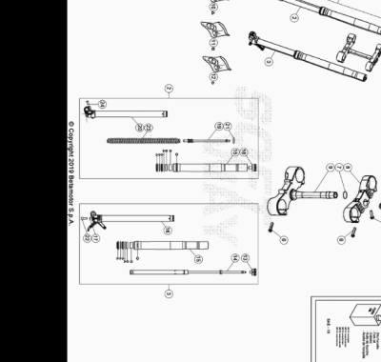

ENDURO_XTRAINER_250_2T_MY22
Ref. | Part Number | Description | Part
1 | 036.34.037.80.00 | HORQUILLA COMPLETA XTRAINER 2T | 1
2 | 036.34.003.80.00 | BARRA HORQUILLA DX | 1
3 | 036.34.036.80.00 | BARRA HORQUILLA SX XTRAINER 2T | 1
4 | 020.34.004.00.00 | TUERCA M 20 X 1,5 HORQUILLA RR 4T MY 10 | 1
5 | 11.55440.000 | TORNILLO C/HEX. 10 M8x30 DIN 933 8.8 | 1
6 | 11.55510.000 | TORNILLO 8.40 ALP 200/08 | 8
7 | 10.66420.000 | ANILLO OR 22-3,53 NBR | 1
8 | 036.34.033.42.59 | PLETINA HORQUILLA | 1
9 | 036.34.034.82.59 | PLETINA COMPLETA | 1
10 | 036.34.007.82.00 | #SK43K# | 1
11 | 036.34.011.82.00 | KIT CASQUILLOS HORQUILLA XTRAINER | 1
12 | 036.34.015.82.00 | KIT ANILLO HORQUILLA XTRAINER | 1
13 | 036.34.017.00.00 | TAPON HORQUILLA | 1
14 | 036.34.040.00.00 | CARTUCHO HIDRAULICO | 1
15 | 036.34.019.00.00 | BOTELLA | 2
16 | 036.34.020.00.00 | BARRA IZQUIERDA | 1
17 | C19.43.007.00.00 | ARANDELA 12.17.1,5 | 1
18 | 036.34.022.00.00 | TAPON HORQUILLA | 1
19 | 036.34.023.00.00 | EJE | 1
20 | 036.34.024.00.00 | BARRA | 1
21 | 036.34.025.00.00 | TAPON | 1
22 | C24.24.046.00.00 | TORNILLO TCCE 12.30 | 1
23 | 036.34.021.00.00 | MUELLE HORQUILLA | 1
24 | 31.63890.000 | TORNILLO ALLEN TCCE 8.20 | 1

ENDURO_XTRAINER_250_2T_MY22
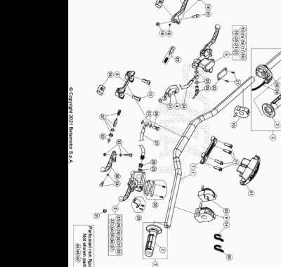

ENDURO_XTRAINER_250_2T_MY22
Ref. | Part Number | Description | Part
1 | 22.20391.000 | MANILLAR ENDURO RR 4T /07 | 1
2 | 036.35.005.00.00 | JUEGO DE PUÑOS ENDURO | 1
3 | 036.35.004.80.00 | MANDO GAS COMPLETO | 1
4 | 11.65053.000 | TORNILLO ESPECIAL TALAD.10..1,25 RR-4T | 1
5 | 21.02057.059 | BOMBA FRENO DELANTERA RR4T RACING | 1
6 | 020.35.020.00.00 | BOMBA EMBRAGUE ENDURO RR 4T 2012 | 1
7 | 12.08253.000 | ABRAZADERA SUPERIOR HORQUILLA RR-4T | 1
8 | 12.08263.000 | ABRAZADERA INF HORQUILLA RR4T 1508050 | 1
9 | 016.35.010.00.00 | MANDO LUCES CON INTERMITENTES ENDURO 2017 | 1
10 | 026.40.047.00.00 | DISPOSITIVO ON/OFF | 1
11 | 31.64070.000 | TORNILLO ESPECIAL 8X25 CH10 | 4
12 | 31.65626.000 | TORNILLO 10X25 RR-4T | 2
13 | 21.27104.000 | MANETA FRENO ANT. FORJADA RR 4T | 1
14 | 15.14264.000 | ABRAZ.PA 6 NY.DENT.NAT.ABNY-B 3,6 X 200 | 3
15 | 31.96832.000 | PASADOR MANETA FRENO | 1
16 | 13.30911.000 | TUERCA PASADOR MANETA FRENO | 1
17 | 16.33841.000 | GOMA RR 4T 2008 | 1
18 | 31.88604.000 | TORINILLO REG | 1
19 | 22.38704.000 | MUELLE REG. BOMBA FRENO | 1
20 | 20.08258.000 | JUEGO PISTON COMPL. BOMBA FRENO ANT. RR-4T | 1
21 | 31.23410.052 | TORNILLO TAPA DEP. LIQUIDO FRENOS | 2
22 | 031.36.003.82.00 | KIT TAPA BOMBA FRENO ANT. RR2T | 1
23 | 16.50510.000 | JUNTA 10.15.1 (COBRE) | 7
24 | 037.36.002.00.00 | TUBO FRENO | 1
25 | 18.89621.000 | INTERRUPTOR STOP RR-4T | 1
26 | 11.65040.000 | TORNILLO ESP. TALAD.10.1 PARA TUBO FRENO | 1
27 | 036.35.001.00.00 | TUBO EMBRAGUE | 1
28 | 020.35.032.00.00 | RACORD BOMBA EMBRAGUE | 1
29 | 020.35.025.00.00 | BRIDA | 1
30 | 020.35.023.00.00 | TAPA DEPOSITO BOMBA EMBRAGUE | 1
31 | 020.35.028.00.00 | ANTIEMULSION | 1
32 | 020.35.029.00.00 | VARILLA DE PRESION | 1
33 | 020.35.024.00.00 | EJE PALANCA | 1
34 | 020.35.030.00.00 | GUIA RESORTE | 1
35 | 020.35.027.00.00 | GOMA PROTECCION PALANCA | 1
36 | 020.35.022.00.00 | MANETA EMBRAGUE RR4T 2012 | 1
37 | 020.35.026.00.00 | KIT PISTON BOMBA | 1
38 | 036.35.002.00.00 | #036.35.002.82.00# | 1
39 | 026.35.010.00.00 | #12.55098.000# | 1
40 | 032.35.049.00.00 | GOMA | 5
41 | 037.43.016.00.59 | PROTECCION MANILLAR | 1
42 | 037.40.004.00.00 | DISPOSITIVO SWITCH MAPA | 1
45 | 12.30100.000 | SOPORTE MANETA FRENO ANT (ESPEJO) | 1
46 | 28.92927.000 | #28.92927.800# | 1
47 | 031.35.008.00.00 | RETROVISOR SX | 1

ENDURO_XTRAINER_250_2T_MY22
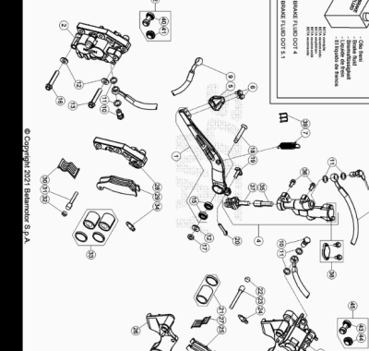

ENDURO_XTRAINER_250_2T_MY22
Ref. | Part Number | Description | Part
1 | 020.36.001.80.00 | PALANCA FRENO ENDURO RR 4T | 1
2 | 25.03056.000 | PINZA FRENO ANTERIOR RR-4T | 1
3 | 25.03066.000 | PINZA FRENO POSTERIOR RR-4T | 1
4 | 25.91178.000 | BOMBA FRENO POSTERIOR ENDURO RR 4T /07 | 1
5 | 22.90053.000 | PUNTERA PEDAL FRENO RR-4T | 1
6 | 11.46251.000 | TORNILLO 5.12 RS CH8 | 2
7 | 22.48813.000 | MUELLE RETORNO PALANCA FRENO RR-4T | 1
8 | 29.09428.000 | TUBO FRENO POSTERIOR ENDURO RR 4T /07 | 1
9 | 037.36.002.00.00 | TUBO FRENO | 1
10 | 11.65053.000 | TORNILLO ESPECIAL TALAD.10..1,25 RR-4T | 2
11 | 16.50510.000 | JUNTA 10.15.1 (COBRE) | 6
12 | 27.49500.000 | ARANDELA PLANA 8.18 | 3
13 | 11.55500.000 | TORNILLO 8.40 PF CH 13 RS | 1
14 | 18.89621.000 | INTERRUPTOR STOP RR-4T | 1
15 | 12.93388.000 | COJINETE 8X22X7 RR-4T | 2
16 | 11.55470.000 | TORNILLO 8.35 PF CH 13 RS | 1
17 | 13.17020.000 | TUERCA M8 AUTOBLOC. BASSO | 1
18 | 31.63985.000 | TORNILLO M 8 X50 | 1
19 | 25.41830.000 | EJE BOMBA POST.RR-4T/07 | 1
20 | 12.81995.000 | PASADOR 2.15 INOX REV 3 | 1
21 | 20.02717.000 | JUEGO PISTON Y GUARNICIÓN PINZA RR-4T | 1
22 | 31.96821.000 | TORNILLO ESP. PASTILLAS PINZAS RR-4T/06 | 1
23 | 25.41860.000 | VARILLA ESP. PASTILLAS PINZAS RR-4T/06 | 1
24 | 28.91002.000 | AIREADOR PINZAS FRENO RR-4T | 1
25 | 25.25362.000 | JUG. PASTILLAS PINZA FRENO POSTERIOR RR-4T | 1
26 | 020.36.011.00.00 | BRIDA SOPORTE PINZA | 1
27 | 22.32208.000 | MUELLE PASTILLAS PINZA RR-4T | 1
28 | 020.36.012.00.00 | BRIDA SOPORTE PINZA ANT. 25.03056. 0.00 | 1
29 | 25.25361.000 | #25.25365.000# | 1
30 | 22.32207.000 | MUELLE PASTILLAS PINZA RR-4T | 1
31 | 25.41859.000 | VARILLA ESP. PASTILLAS PINZAS RR-4T/06 | 1
32 | 31.96821.000 | TORNILLO ESP. PASTILLAS PINZAS RR-4T/06 | 1
33 | 20.02716.000 | JUEGO PISTON Y GUARNICIÓN PINZA RR-4T | 1
34 | 28.91001.000 | AIREADOR PASTILLAS PINZA RR-4T | 1
35 | 20.08276.000 | JUEGO PISTON BOMBA FRENO RR 4T 2008 | 1
36 | 31.30750.000 | TORNILLO TBIB 6.16 | 2
37 | 20.08277.000 | KIT LEVA BOMBA FRENO | 1
38 | 20.08275.000 | KIT DEPOSITO BOMBA RR 4T 2008 | 1
39 | 25.24442.000 | GUIA CABLE 6/8 RR-4T / RR 125 / RR-T | 1
40 | 036.36.002.00.00 | PROTECCION | 1
41 | 036.36.003.00.00 | PROTECCION | 1
42 | 036.36.006.82.00 | PROTECCION ANTERIOR | 1
43 | 036.36.004.00.00 | PROTECCION | 1
44 | 036.36.005.00.00 | PROTECCION | 1
45 | 036.36.007.82.00 | PROTECCION POSTERIOR | 1

ENDURO_XTRAINER_250_2T_MY22
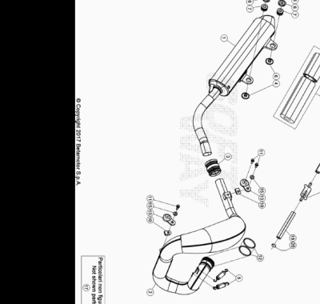

ENDURO_XTRAINER_250_2T_MY22
Ref. | Part Number | Description | Part
1 | 036.37.010.80.00 | SILENCIOSO COMPLETO | 1
2 | 036.37.000.45.00 | COLECTOR ESCAPE MAM 2T CMPL-GARA / XTRAINER | 1
3 | 026.37.103.00.00 | MANGUITO SILENCIOSO | 1
4 | 036.37.007.00.00 | DISTANCIADOR | 1
5 | 026.37.005.00.00 | MUELLE ESCAPE | 2
6 | 026.37.006.00.00 | DISTANCIADOR ESCAPE | 3
7 | 032.37.013.00.00 | SILENT-BLOCK | 2
8 | 29.15852.000 | TUBO VALVULA/FILTRO AL 4.0 2008 | 1
9 | 11.50300.000 | TORNILLO 6,30 RS CH 8 RR-4T / RR 125 | 1
10 | 25.60311.000 | GRAPA TORNILLO M6 ALP 4.0 2008 | 2
11 | 11.48025.000 | TORNILLO HEX/C.ARO 6x16 ( RS-T.8 ) | 3
12 | 10.66930.000 | TORICA OR 43.3 VYTON (OR M 0430-30) | 2
13 | 28.91943.000 | SILENT-BLOCK ESCAPE KIT RR GARA FE | 2
14 | 036.37.110.82.00 | #026.37.007.82.00# | 1
15 | 27.42000.000 | ARANDELA PLANA 6.18 | 2
16 | 11.50360.000 | TORNILLO 6X40 | 1
17 | 026.37.016.80.00 | COLECTOR ESCAPE COMPLETO | 1
18 | 31.15070.000 | VALVULA AIRE RR4T EURO3 | 1
19 | 29.15858.000 | TUBO | 1
20 | 10.67470.000 | ARANDELA CAJA FILTRO | 1

ENDURO_XTRAINER_250_2T_MY22
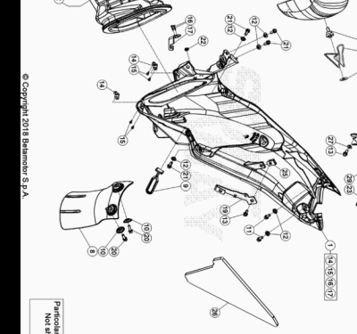

ENDURO_XTRAINER_250_2T_MY22
Ref. | Part Number | Description | Part
1 | 036.38.014.80.59 | CAJA FILTRO | 1
2 | 026.38.001.00.00 | MANGUITO CAJA FILTRO RR 2T | 1
3 | 026.38.002.00.00 | JAULA FILTRO AIRE RR2T | 1
4 | 031.38.001.00.00 | FILTRO AIRE RR 2T/4T | 1
5 | 25.57197.000 | EJE FILTRO RR-4T - RR 125 | 1
6 | 020.38.021.00.00 | MUELLE FILTRO | 1
7 | 27.74800.000 | ARANDELA 9 RR-4T - RR 125 | 1
8 | 036.38.009.10.59 | PROTECCION AMORTIGUADOR | 1
9 | 16.34907.000 | GOMA CABALLETE RR-4T | 1
10 | 27.74786.000 | ARANDELA RR-4T | 2
11 | 31.79960.000 | TORNILLO AUTOROSCANTE M6x15 | 2
12 | 13.54820.000 | DISTANCIADOR RR-4T | 6
13 | 11.47015.000 | TORNILLO 6.12 REV3-04 - RR-4T | 2
14 | 026.38.004.00.00 | GRAPA CAJA FILTRO | 2
15 | C18.19.009.00.00 | REMACHE 2,5 X 8 | 4
16 | 27.33803.000 | REMACHE 3x12 | 2
17 | 036.38.008.15.00 | SOPORTE MUELLE FILTRO AIRE | 1
18 | 15.14272.000 | BRIDA FIJACIÓN RR-4T | 1
19 | 031.40.127.22.00 | SOPORTE | 1
20 | 31.30815.000 | TORNILLO AUTOROSC. 6 X 20 | 2
21 | 11.48025.000 | TORNILLO HEX/C.ARO 6x16 ( RS-T.8 ) | 4
22 | 16.34906.000 | GOMA PORTACARGA | 1
23 | 036.38.001.10.59 | TAPA CAJA FILTRO | 1
24 | 036.40.045.15.00 | SOPORTE INSTALACION ELECTRICA | 1
25 | 25.60311.000 | GRAPA TORNILLO M6 ALP 4.0 2008 | 1
26 | 036.38.005.00.00 | PROTECTOR ESPONJA | 1
27 | 27.42000.000 | ARANDELA PLANA 6.18 | 1
28 | 021.38.019.82.00 | FILTRO AIRE | 1
29 | 25.58060.000 | GRAPA CABLEADO M5 B-4 | 1
30 | 11.46251.000 | TORNILLO 5.12 RS CH8 | 1

ENDURO_XTRAINER_250_2T_MY22
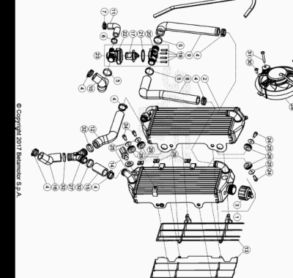

ENDURO_XTRAINER_250_2T_MY22
Ref. | Part Number | Description | Part
1 | 036.39.001.80.00 | RADIADOR DX | 1
2 | 036.39.000.00.00 | RADIADOR SX XTRAINER 300CC 2015 | 1
3 | 036.39.008.00.00 | TAPON RADIADOR | 1
4 | 15.15240.000 | BRIDA 17/29 VELOXBLOC 3B | 6
5 | 020.39.008.00.00 | ABRAZADERA 24 | 3
6 | 020.39.009.00.00 | ABRAZADERA 17 | 1
7 | 15.15220.000 | BRIDA 12/20 APA SX9-C-W1 | 1
8 | 036.39.002.00.00 | TUBO TERMOSTATO SUPERIOR DX | 1
9 | 036.39.003.00.00 | TUBO TERMOSTATO SUPERIOR SX | 1
10 | 036.39.004.00.00 | TUBO TERMOSTATO INFERIOR DX | 1
11 | 036.39.005.00.00 | TUBO TERMOSTATO INFERIOR SX | 1
12 | 036.39.006.00.00 | TUBO RADIADOR | 1
13 | 036.39.007.00.51 | JUEGO REJILLAS RADIADOR XTRAINER | 1
14 | 036.39.009.00.00 | TERMOINTERRUPTOR 90/85 XTRAINER 15/17 | 1
15 | 036.39.010.00.00 | TUBO RADIADOR DX | 1
16 | 036.39.011.00.00 | TUBO BOMBA AGUA | 1
17 | 026.39.013.00.00 | TERMOSTATO RR 2T | 1
18 | 026.39.007.00.00 | TUBO VENTILACION RADIADOR | 1
19 | 031.39.017.50.00 | TORNILLO ESPECIAL M 3, 5X18 | 4
20 | 031.39.016.00.00 | TAPA TERMOSTATO | 1
21 | 10.66830.000 | TORICA OR 32X2 REV4T | 1
22 | 031.39.015.00.00 | CONTENEDOR TERMOSTATO | 1
23 | 026.39.020.80.00 | TERMOSTATO | 1
24 | 11.47015.000 | TORNILLO 6.12 REV3-04 - RR-4T | 4
25 | 27.43250.000 | ARANDELA PLANA 6.24 | 4
26 | 16.34911.000 | GOMA RADIADOR RR-4T | 4
27 | 020.39.020.00.00 | RACORD A "Y" | 1
28 | 021.39.002.00.00 | ELECTROVENTILADOR VEM125 | 1
29 | 25.58065.000 | CLIP M5 | 3
30 | 31.29828.000 | TORNILLO DIN 7380+ARANDELA M-05 X 012 ZN | 2
31 | 31.29886.000 | TORNILLO TBCE 5.35 | 1
32 | C07.16.005.00.00 | ABRAZADERA D.25 | 3

ENDURO_XTRAINER_250_2T_MY22
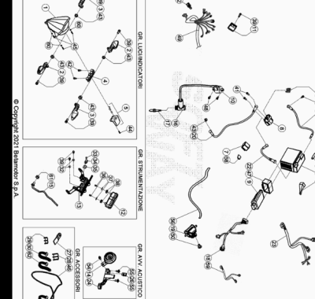

ENDURO_XTRAINER_250_2T_MY22
Ref. | Part Number | Description | Part
1 | 16.46210.000 | #031.40.006.00.00# | 1
2 | 020.40.061.00.00 | INTERMITENTE ANT SX - POST.DX | 2
3 | 020.40.060.00.00 | INTERMITENTE ANT DX - POST SX | 2
4 | 024.40.056.00.00 | FARO TRASERO | 1
5 | 020.40.020.00.00 | LUZ MATRICULA | 1
6 | 11.15416.000 | BATERIA ENDURO RR 4T 2010 ( YTX5L-BS ) | 1
7 | 18.84948.000 | INTERMITENCIA ALP 200/08 | 1
8 | 27.28471.000 | RELE ARRANQUE RR 2T/ 4T | 1
9 | 036.40.032.83.00 |  | 1
10 | 036.40.009.00.00 | BOBINA | 1
11 | 27.28101.000 | REGULADOR RR-4T | 1
12 | 040.40.004.00.00 | INSTRUMENTO DIGITAL RR 2T | 1
13 | 036.40.042.00.59 | SOPORTE RELOJ DIJITAL XTRAINER | 1
14 | 007.40.050.00.00 | AVISADOR ACUSTICO SCOOTER | 1
15 | 031.40.166.00.00 | SENSOR RED | 1
16 | 27.13514.000 | PIPA BUJIA | 1
17 | 036.11.001.00.00 | BUJIA IRIDIO T40352G ( NGK IR - GR7CI 8 ) | 1
18 | 036.40.044.00.00 | INSTALACION ELECTRICA PRINCIPAL XTRAINER 2T | 1
19 | 026.40.017.00.00 | BOMBA ACEITE | 1
20 | 026.40.006.00.00 | CABLE RELE ARRANQUE | 1
21 | 036.40.011.00.00 | CABLE DE MASA | 1
22 | 020.40.003.00.00 | CABLE BATERIA-RELE | 1
23 | 036.40.047.00.00 | CABLEADO SECUNDARIO TRASERO XTRAINER | 1
24 | 037.40.023.00.59 | SOPORTE AVISADOR ACUSTICO | 1
25 | 031.40.052.00.00 | DIODO | 1
26 | 25.60311.000 | GRAPA TORNILLO M6 ALP 4.0 2008 | 1
27 | 036.32.004.15.00 | SOPORTE | 1
28 | 25.24442.000 | GUIA CABLE 6/8 RR-4T / RR 125 / RR-T | 3
29 | 25.24443.000 | GUIA CABLE 6/6 RR-4T / RR 125 / RR-T | 3
30 | 15.14264.000 | ABRAZ.PA 6 NY.DENT.NAT.ABNY-B 3,6 X 200 | 4
31 | 31.31040.000 | TORNILLO TCEI 6.12 | 1
32 | 13.54820.000 | DISTANCIADOR RR-4T | 2
33 | 31.23600.000 | TORNILLO ROSCA CHAPA 4,2.13 TMTIC | 1
34 | 25.25182.000 | ABRAZADERA | 1
35 | 25.58090.000 | GRAPA PARA TORNILLO AUTOF.4,2 | 1
36 | C24.22.009.00.00 | TORNILLO M 4 X 10 DIN 7687 | 2
37 | 27.34800.000 | ARANDELA TRANCIATA 4.16 | 2
38 | 024.40.039.00.00 | SILENT BLOCK | 2
39 | 11.48025.000 | TORNILLO HEX/C.ARO 6x16 ( RS-T.8 ) | 7
40 | 020.40.006.00.00 | FUSIBLE 10 A | 2
41 | 31.30190.000 | TORNILLO ALLEN TCCE 6.8 | 2
42 | 11.46360.000 | TORNILLO 5X16 LLAVE 8rs RR-4T | 2
43 | 13.12550.000 | TUERCA M6.5 FLAN. | 5
44 | 31.23565.000 | TORNILLO 4,5 X 15 TCCCR ALP 200/08 | 1
45 | 31.26190.000 | TORNILLO M. 4 X 12 TCIC | 3
46 | 14.40020.000 | GOMA SUJETA BATERIA | 1
47 | 007.40.034.00.00 | GOMA CENTRALITA | 1
48 | 31.31050.000 | TORNILLO ALLEN TCCE 6.15 | 2
49 | 036.40.046.00.00 | CABLEADO SECUNDARIO DELANTERO | 1
50 | 31.95510.000 | TORNILLO DIN 7380+ARANDELA M-06 X 012 ZN | 1
51 | 032.35.049.00.00 | GOMA | 1
52 | 037.40.115.00.00 |  | 1
54 | 11.46501.000 | TORNILLO ENCAJE M6.10 RSCH8 | 1
55 | 037.43.028.00.00 | TORNILLO ESPECIAL M6X8 | 2
56 | 036.43.030.00.00 | TUBO ACEITE | 1
57 | 031.40.051.00.00 | CONDENSADOR | 1
58 | 031.40.002.22.00 | BRIDA SOPORTE INTERMITENCIA | 1
59 | 026.40.057.00.00 | INSTALACION ELECTRICA DIAGNOSIS | 1
60 | 27.34650.000 | ARANDELA PLANA 4x9 DIN 125/A | 3
61 | 13.17121.000 | TUERCA M8 BASE CILINDRO CH.10 | 1
62 | 037.40.026.00.00 | ABRAZADERA | 6

ENDURO_XTRAINER_250_2T_MY22
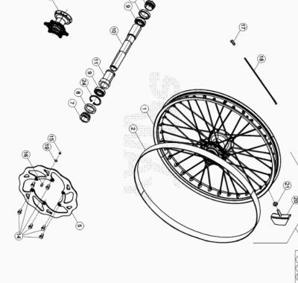

ENDURO_XTRAINER_250_2T_MY22
Ref. | Part Number | Description | Part
1 | 036.41.007.00.59 | LLANTA ANTERIOR | 1
2 | 15.38200.000 | SALVACAMARA 750x25-21" RR-4T / RR 125 | 1
5 | 031.41.030.00.00 | #031.41.030.82.00# | 1
7 | 036.41.005.00.00 | DISTANCIADOR BUJE ANTERIOR | 2
8 | 10.66000.000 | RETEN 35X47X7 RR-4T | 2
9 | 020.41.003.00.00 | #12.99520.000# | 2
10 | 036.41.004.00.00 | EJE RUEDA ANTERIOR | 1
11 | 031.41.015.00.00 | DISTANCIADOR INTERIOR BUJE DELANTERO | 1
14 | 031.41.043.00.00 | TORNILLO ESP. M 6X14 | 6
15 | 28.22660.000 | SEEGER 9E | 1
16 | 021.41.005.00.00 | MAGNETO DIAM. 9 PER SENSORE HALL | 1
17 | 036.41.003.00.00 | CABECILLA RADIO RUEDA ANTERIOR | 36
18 | 036.41.002.00.00 | RADIO RUEDA ANTERIOR | 36
19 | 27.58080.000 | ARANDELA 9 X 13 X 0.4 ENDURO RR 125 | 1
20 | 036.41.010.00.00 | AGARRE CUBIERTA | 1
21 | 13.17120.000 | TUERCA M8 BASE CILINDRO | 1
22 | 036.41.009.00.59 | RUEDA ANTERIOR MONTADA ( LLANTA,BUJE,RADIOS ) | 1
23 | 031.41.014.80.00 | BUJE ANT. C/COJI. Y DIST.INTERNO RR 4T | 1
24 | C01.26.001.00.00 | SEEGER D: 47 X 1,75 | 1

ENDURO_XTRAINER_250_2T_MY22
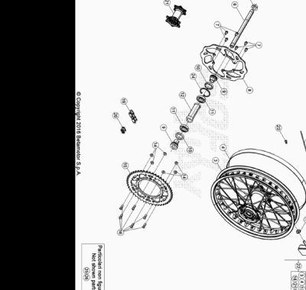

ENDURO_XTRAINER_250_2T_MY22
Ref. | Part Number | Description | Part
3 | 036.42.007.00.59 | LLANTA RUEDA TRASERA 18.1,85-36 | 1
4 | 15.36000.000 | SALVACAMARA 575x25-18 | 1
5 | 13.27120.000 | TUERCA ESPECIAL RUEDA POSTERIOR RR-4T | 1
6 | 25.55812.000 | EJE RUEDA POSTERIOR RR-4T | 1
7 | 031.41.016.00.00 | #031.41.043.00.00# | 6
8 | 031.42.030.00.00 | #031.42.030.82.00# | 1
9 | 031.42.002.00.00 | DISTANCIADOR BUJE POST. RR 4T | 2
10 | 10.66000.000 | RETEN 35X47X7 RR-4T | 2
11 | 020.42.004.00.00 | #12.99280.000# | 2
12 | 031.42.005.00.00 | DIST.INTERNO RUEDA POST. RR4T | 1
13 | 036.42.004.00.00 | RADIO RUEDA POSTERIOR | 36
14 | 13.17123.000 | TUERCAS M8 | 6
15 | 026.42.005.00.00 | CORONA Z49 | 1
16 | 31.96827.000 | TORNILLO TGS M8X26 10.9 DACR | 6
17 | 13.17120.000 | TUERCA M8 BASE CILINDRO | 1
18 | 15.17550.000 | #15.17541.000# | 1
19 | 031.42.003.00.00 | CADENA 520 VF ( DID CON RETENES )CADENA P. 114 RR4T/2T | 1
20 | 031.42.008.00.00 | ENGANCHE CADENA 5/8X1/4 | 1
21 | 031.42.014.80.00 | BUJE POSTERIOR C/ COJINETES | 1
22 | 036.42.008.00.59 | RUEDA POSTERIOR | 1
23 | 036.42.005.00.00 | CABECILLAS RADIO POSTERIOR | 36
24 | C01.26.001.00.00 | SEEGER D: 47 X 1,75 | 1
25 | 026.42.013.00.00 | CORONA Z 42 | 1
26 | 12.08204.000 | CADENA 5/8X1/4 p.112 RR-4T | 1

ENDURO_XTRAINER_250_2T_MY22
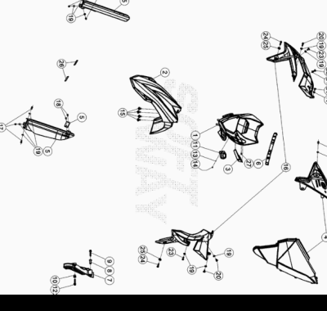

ENDURO_XTRAINER_250_2T_MY22
Ref. | Part Number | Description | Part
1 | 036.43.046.00.51 | PORTAFARO XTRAINER MY 20 | 1
2 | 037.43.009.00.51 | GUARDABARROS ANTERIOR | 1
3 | 037.43.017.00.51 | PASACABLES | 1
4 | 026.43.021.00.51 | JUEGO TAPAS FILTRO XTRAINER | 1
5 | 021.45.008.00.51 | KIT PROTECTORES HORQUILLA ENDURO | 1
6 | 037.43.020.00.59 | GOMA PORTAFARO | 1
7 | 040.43.005.00.59 | PROTECCION PIÑON | 1
8 | 13.49189.000 | DISTANCIADOR RR-4T/06 | 1
9 | 11.50300.000 | TORNILLO 6,30 RS CH 8 RR-4T / RR 125 | 1
10 | 13.49190.000 | DISTANCIADOR RR-4T / RR 125 | 1
11 | 25.24464.000 | BRIDA RR 4T 2008 | 1
12 | 11.50355.000 | TORNILLO ANCLAJE M6X35 RS CH 8 | 1
13 | 27.34650.000 | ARANDELA PLANA 4x9 DIN 125/A | 1
14 | 31.23566.000 | TORNILLO ROSCA 4,5x9 | 1
15 | 037.43.029.00.00 | TORNILLO ESP. M 6 X 12 | 4
16 | 036.43.045.00.51 | JUEGO PLACAS RADIADOR | 1
17 | 11.47015.000 | TORNILLO 6.12 REV3-04 - RR-4T | 6
18 | 31.79960.000 | TORNILLO AUTOROSCANTE M6x15 | 2
19 | 13.54820.000 | DISTANCIADOR RR-4T | 13
20 | 31.95510.000 | TORNILLO DIN 7380+ARANDELA M-06 X 012 ZN | 4
21 | 13.62000.000 | DISTANCIADOR DISCO TR ( 6x14x7.5 ) | 1
22 | 31.30035.000 | TORNILLO M6x16 TBCEI URBAN /08 | 1
23 | 11.48025.000 | TORNILLO HEX/C.ARO 6x16 ( RS-T.8 ) | 3
24 | 11.49070.000 | TORNILLO 6X20 RS CH8 | 2
25 | 020.43.012.00.00 | DISTANCIADOR PLACA RADIADOR | 2
26 | 12.33062.000 | REFLECTOR LATERAL RR-4T / RR 125 | 2
27 | 31.23580.000 | TORNILLO 4,8X13_x000D_ | 1

ENDURO_XTRAINER_250_2T_MY22
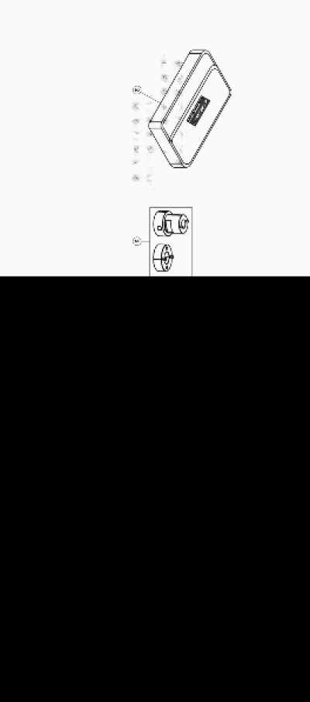

ENDURO_XTRAINER_250_2T_MY22
Ref. | Part Number | Description | Part
1 | 036.44.044.83.00 | PEN DRIVE USO Y MANTENIMIENTO XTRAINER MY 22 | 1
2 | 036.44.002.80.00 | BOLSA HERRAMIENTAS | 1
3 | 036.44.008.82.00 | UTILAJES HORQUILLA | 1

ENDURO_XTRAINER_250_2T_MY22
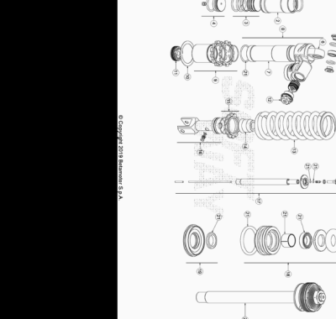

ENDURO_XTRAINER_250_2T_MY22
Ref. | Part Number | Description | Part
1 | 036.33.030.80.00 | AMORTIGUADOR XTRAINER 2T | 1
2 | 036.33.010.00.00 | DEPOSITO AMORTIGUADOR | 1
3 | 036.33.011.00.00 | GRUPO DIAFRAGMA | 1
4 | 036.33.012.00.00 | GRUPO TAPON DEPOSITO | 1
5 | 036.33.013.00.00 | KIT ROTULAS AMORTIGUADOR | 1
6 | 036.33.014.00.00 | SOPORTE | 1
7 | 036.33.015.00.00 | CUERPO AMORTIGUADOR | 1
8 | 036.33.016.00.00 | GRUPO CUERPO | 1
9 | 036.33.017.00.00 | GRUPO CASQUILLOS | 1
10 | 036.33.018.00.00 | ARANDELA | 1
11 | 036.33.019.00.00 | PISTON | 1
12 | 036.33.020.00.00 | GRUPO REGULACION COMPRESION | 1
13 | 036.33.021.00.00 | MUELLE AMORTIGUADOR | 1
14 | 036.33.022.00.00 | TAPON | 1
15 | 036.33.023.00.00 | KIT SEEGERS Y ARANDELAS AMORTIGUADOR | 1
16 | 036.33.024.00.00 | GRUPO HORQUILLAS | 1
17 | 036.33.025.00.00 | GRUPO ESPIGA | 1
18 | 036.33.026.00.00 | GRUPO GUIA | 1
19 | 036.33.027.00.00 | KIT RETENES | 1
20 | 036.33.028.00.00 | VARILLA COMPLETA | 1
21 | 036.33.029.00.00 | KIT JUNTAS | 1

ENDURO_XTRAINER_250_2T_MY22
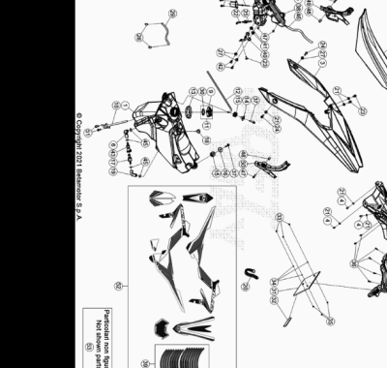

ENDURO_XTRAINER_250_2T_MY22
Ref. | Part Number | Description | Part
1 | 036.43.034.00.59 | DEPOSITO GASOLINA | 1
2 | 036.43.048.00.00 | ASIENTO XTRAINER 2T MY 20 | 1
3 | 036.43.003.10.51 | GUARDABARROS POSTERIOR | 1
4 | 11.47015.000 | TORNILLO 6.12 REV3-04 - RR-4T | 5
5 | 036.43.010.00.00 | TAPON DEPOSITO ACEITE | 1
6 | 036.43.012.00.00 | TUBO GASOLINA | 1
7 | 036.43.006.10.59 | PORTAMATRICULAS RR 2T/4T | 1
8 | 020.43.034.10.59 | PORTAMATRICULA RR4T MY10 HOMLOLOGADO NEGRO | 1
9 | 036.43.041.80.00 | TAPON DEPOSITO GASOLINA | 1
10 | 036.43.039.00.00 | GRIFO GASOLINA | 1
11 | 036.43.041.82.00 | TAPON GASOLINA COMPLETO | 1
12 | 020.43.003.00.00 | TUBO TAPON-VALVULA PURGA AIRE | 1
13 | 026.43.029.00.00 | GOMA | 1
14 | 020.43.002.00.00 | DISTANCIADOR DEPOSITO GASOLINA | 1
15 | 032.37.013.00.00 | SILENT-BLOCK | 2
16 | 031.43.002.00.00 | DISTANCIADOR DEPOSITO GASOLINA | 1
17 | 036.43.013.00.00 | CONECTOR | 1
18 | 31.89010.000 | TORNILLO BLOQUEO SILLÍN RR-4T / RR 125 | 1
19 | 036.43.011.00.00 | TUBO GASOLINA | 1
20 | 15.14264.000 | ABRAZ.PA 6 NY.DENT.NAT.ABNY-B 3,6 X 200 | 1
21 | 13.54820.000 | DISTANCIADOR RR-4T | 6
22 | 036.43.022.00.00 | TUBO ACEITE | 1
23 | 31.95510.000 | TORNILLO DIN 7380+ARANDELA M-06 X 012 ZN | 3
24 | 11.48025.000 | TORNILLO HEX/C.ARO 6x16 ( RS-T.8 ) | 2
25 | 036.43.017.00.00 | RACORD | 1
26 | 026.40.019.00.00 | SENSOR NIVEL | 1
27 | 13.62000.000 | DISTANCIADOR DISCO TR ( 6x14x7.5 ) | 3
28 | C07.08.008.00.00 | BRIDA CE 12 | 2
29 | 026.43.005.00.00 | TUBO GASOLINA DEP/CARBURAT. RR 2T | 1
30 | 031.43.116.00.00 | JUNTA TAPON GASOLINA | 1
31 | 018.43.010.10.59 | SOPORTE MATRICULA | 1
32 | 12.33086.000 | REFLECTOR POSTERIOR RR.4T 7 RR 125 | 1
33 | 13.11010.000 | TUERCA M5 AUTOBLOC. | 3
34 | 27.36000.000 | ARANDELA PLANA 5.11 | 3
35 | 31.29860.000 | TORNILLO TTLIC 5.16 CABEZA 10 | 3
36 | 31.79960.000 | TORNILLO AUTOROSCANTE M6x15 | 6
37 | 11.50300.000 | TORNILLO 6,30 RS CH 8 RR-4T / RR 125 | 2
38 | 026.43.007.10.51 | DEPOSITO ACEITE MIX | 1
39 | 036.43.054.82.00 | SERIE ADHESIVOS LLANTA XTRAINER MY 21 | 1
40 | 036.43.021.22.00 | BRIDA BOMBA ACEITE | 1
41 | 16.34906.000 | GOMA PORTACARGA | 2
42 | 31.30470.000 | TORNILLO TBCE 6.6 | 2
43 | 031.40.027.00.00 | CONECTOR TUBO GASOLINA | 1
45 | C07.16.002.00.00 | GRAPA NORMA 13/8 W4 | 4
46 | 036.43.028.14.00 | TUBO | 1
47 | 11.49070.000 | TORNILLO 6X20 RS CH8 | 4
48 | 27.33740.000 | REMACHE M. 6 | 2
49 | 036.43.027.10.59 | #036.43.029.00.59# | 1
50 | 036.43.026.10.59 | #036.43.029.00.59# | 1
51 | 11.46251.000 | TORNILLO 5.12 RS CH8 | 2
52 | 036.43.056.82.00 | SERIE ADHESIVOS XTRAINER MY 22 | 1
53 | 041.43.008.82.00 | CONTENEDOR FILTRO KIT 2T | 1

